1.**Front-message-auth** — показывать иконки **update/destroy только** для сообщений **auth**-

пользователя, **остальные** сообщения — показывать **без** иконок:

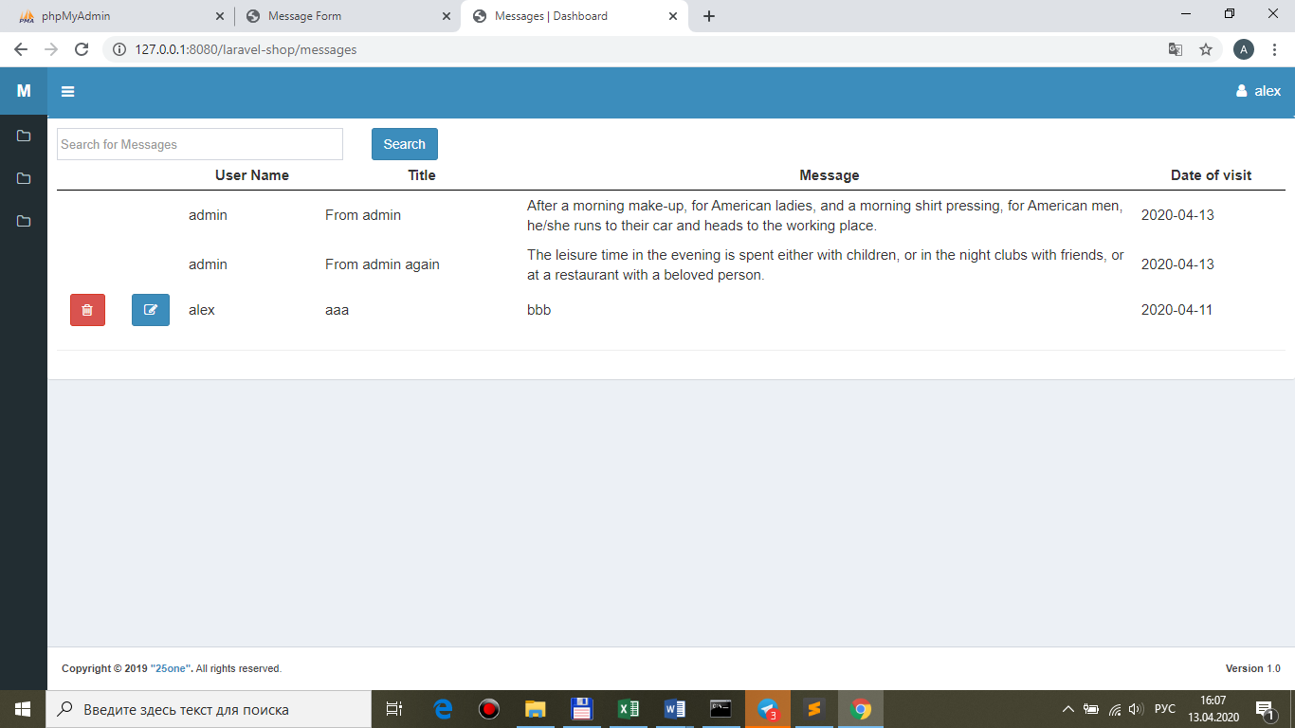

…но, это не должно касаться **admin** – **иконки для всех** messages:

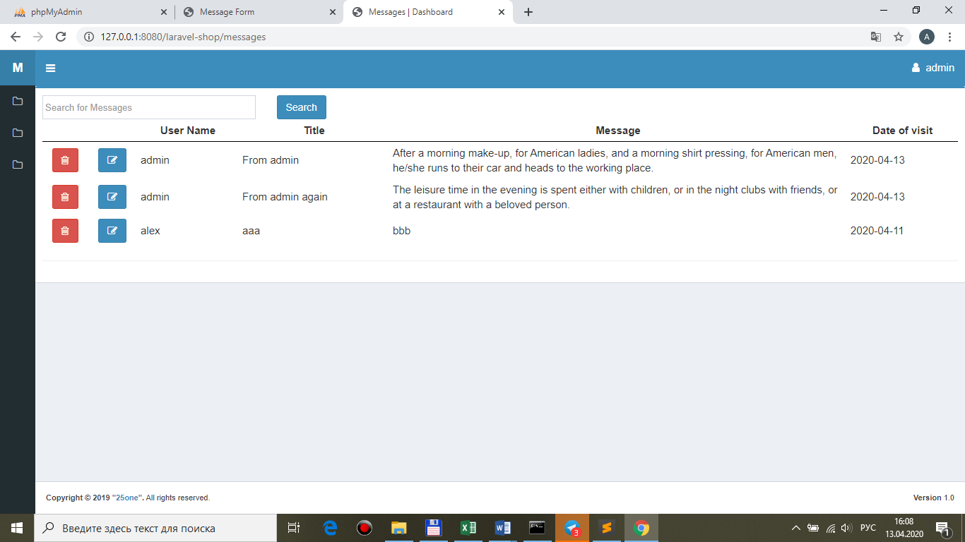

**views/front/messages/brick-standard.blade.php**

@foreach($messages as $message)

<tr>

**@if($message->user_id == auth()->user()->id || auth()->user()->role == 'admin')**

<td class="center widthbutton"><a class="btn btn-danger listbuttonremove" href="#"><i class="fa fa-trash-o" aria-hidden="true"></i></a></td>

<td class="col-md-6 col-sm-6 col-xs-6 center widthbutton"><a class="btn btn-primary listbuttonupdate" href="#"><i class="fa fa-edit" aria-hidden="true"></i></a></td>

**@else**

<td class="center widthbutton"></td>

<td class="col-md-6 col-sm-6 col-xs-6 center widthbutton"></td>

**@endif**

<td>{{ $message->user->name }}</td>

<td>{{ $message->title }}</td>

<td>{{ $message->message }}</td>

<td>{{ $message->datevisit }}</td>

</tr>

@endforeach

2.**Count** содержимого **корзины** (**Cart (2)**).

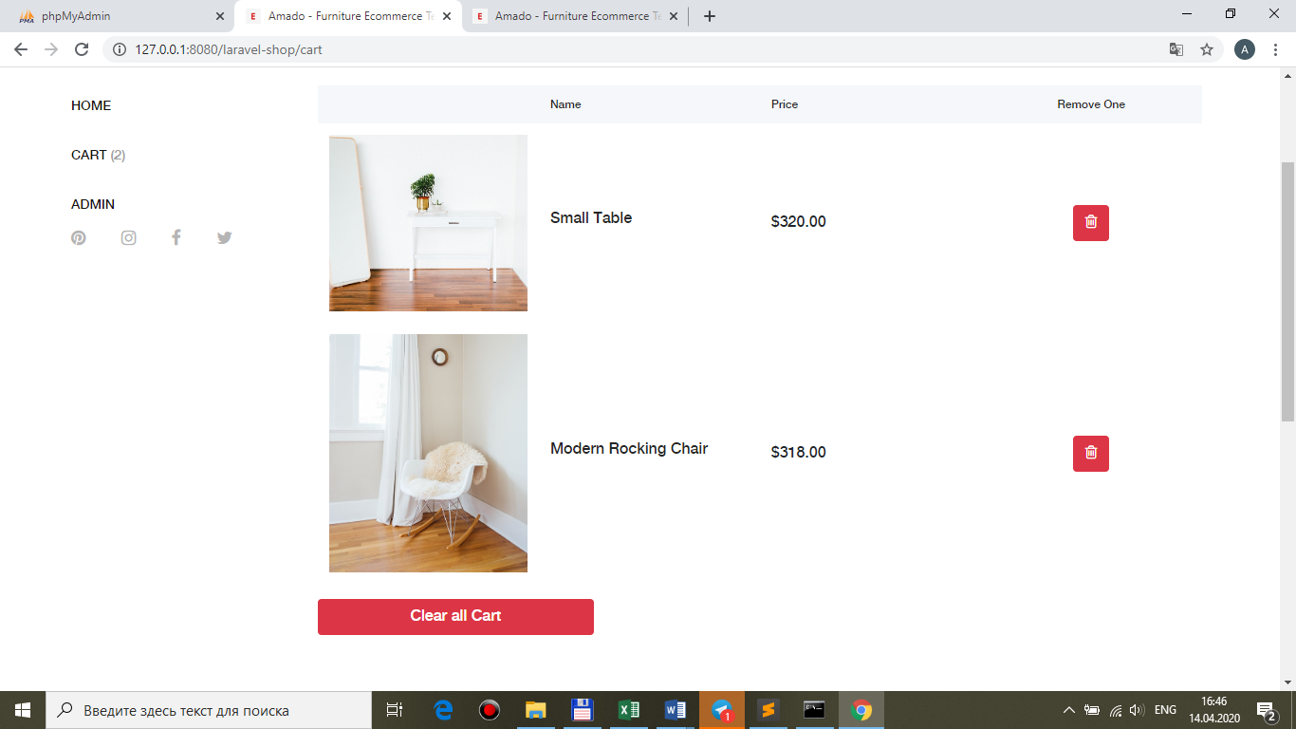

**app\Http\ViewComposers\CartComposer.php**

<?php

namespace App\Http\ViewComposers;

use Illuminate\View\View;

**use App\Models\Cart;**

class **Cart**Composer

{

/**

* Bind data to the view.

*

* @param View $view

* @return void

*/

public function compose(View $view)

{

if(**auth()->user()**) $view->with('carts', Cart::select('id')->**where('user_id', auth()->user()->id)**->get());

else $view->with(**'carts', 0**); }

}

**app\Providers\AppServiceProvider.php**

…

use App\Http\ViewComposers\CartComposer;

…

public function boot()

{

…

view()->composer(**'front/layout', CartComposer::class**);

}

**views\front\layout.blade.php**

@auth

<li><div class="cart-fav-search"><a href="{{route('cart')}}">Cart <span>(**@if($carts){{count($carts)}}@else{{0}}@endif**)</span></a></div></li>

@endauth